Jenkins Assignment 1
Deploying index.html on httpd
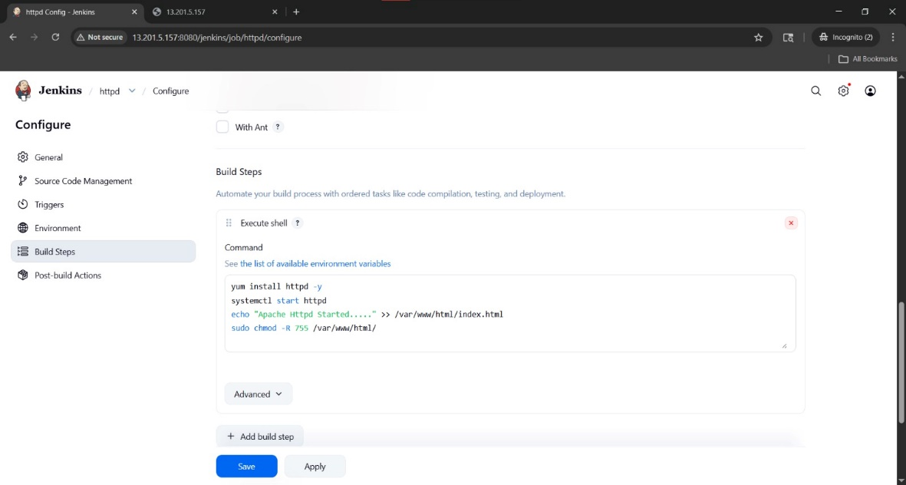

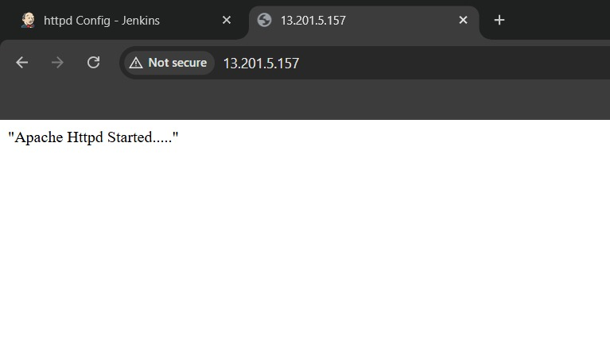

Using pipeline script
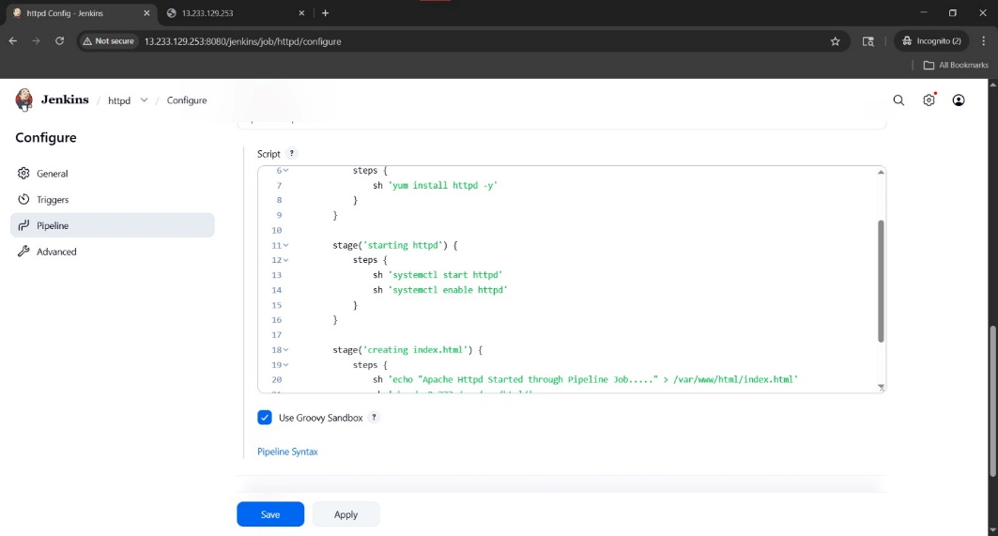

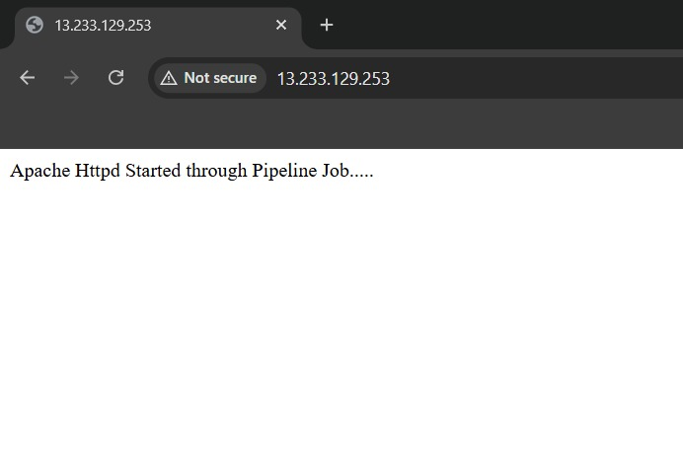

Using pipeline script from SCM/Jenkinsfile
pipeline{
agent any
stages{
stage('install httpd'){
steps{
sh 'yum install httpd -y'
sh 'systemctl start httpd'
sh 'systemctl enable httpd'
}
}
stage('make file'){
steps{
sh 'echo "This is index file" >> /var/www/html/index.html'
sh 'chmod -R 777 /var/www/html/'
}
}
}
}

